**Inter VLAN routing router on a stick**

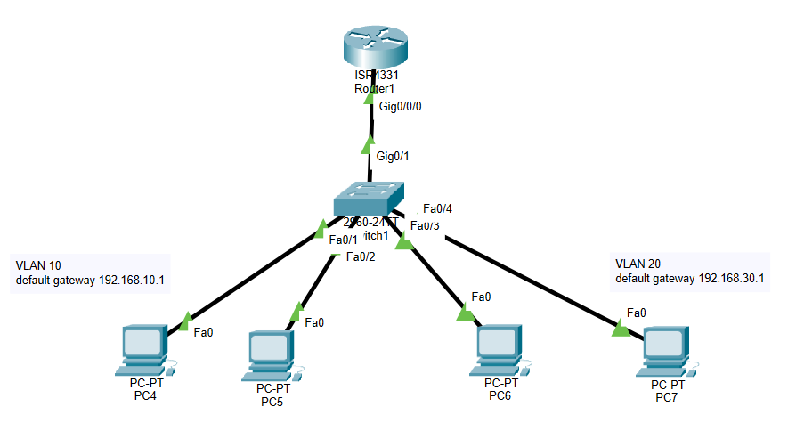

**Task 1: Creating VLANS**

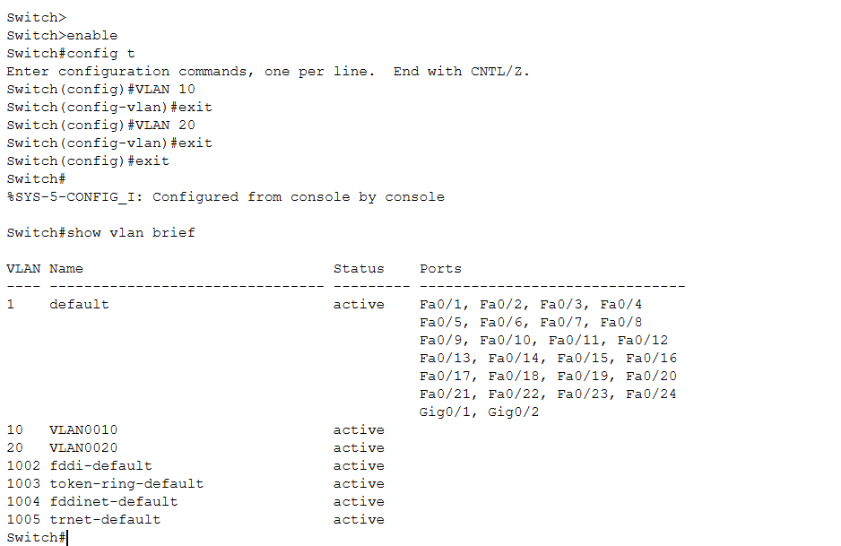

**Task 2: Assigning interface to VLANS**

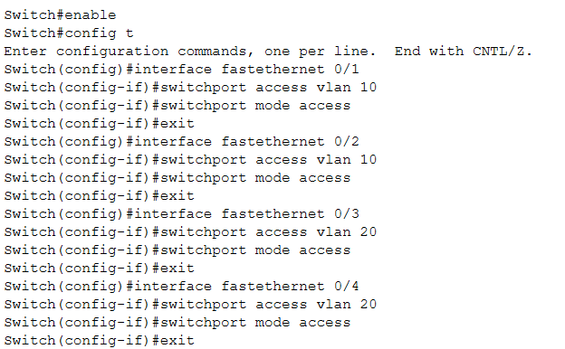

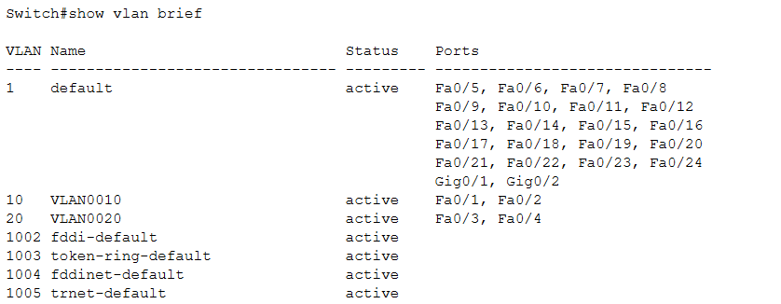

**Task 3: making trunk port of switch**

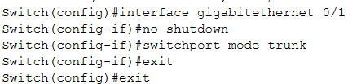

**Task 4: creating sub interface on router interface for both VLANS default gateways**

